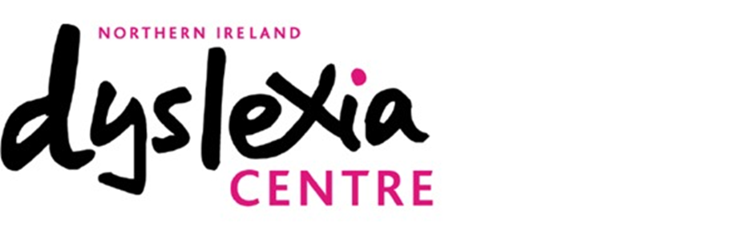

Owner:- John Clarke: Telephone: 02890 654670 Website: www.nidyslexiacentre.co.uk Email: info@nidyslexiacentre.co.uk. Address 17a Upper Newtownards Rd, Belfast, BT4 3HT

Consent Form for .............................................................. Date of Birth ...............................
This form explains the reasons why and how NI Dyslexia Centre may use both traditional mailing and digital tools (Skype, Zoom, email etc) to deliver tuition, associated support, and general Centre communications which involves processing personal data under data protection laws. To enable us to comply with our obligations under the General Data Protection Regulation, we are required to obtain express consent for the use of your/your child’s personal information to use both traditional mailing and digital tools (Skype, Zoom, email etc) to deliver tuition, associated support and general Centre communications. Without your consent we will not use either traditional mailing and digital tools (Skype, Zoom, email etc) to deliver tuition, associated support and general communications. The NI Dyslexia Centre is using these means to support, supplement, complement or replace face to face tuition in the centre where that is not possible or sufficient for whatever reason. It is also using these means to communicate relevant news, events or developments at the Centre. The primary aim is to maintain the high standards of bespoke tuition and support we strive to achieve at the Centre and to maintain effective communication to maximise your access to our specialist services and events.
A pupil aged 13 or above and who is considered capable of giving their own consent can complete this form on their own behalf.
Parents/legal guardians of pupils under the age of 13 or pupils over the age of 13 and not considered capable of giving their own consent should complete this form on behalf of the pupil. This consent form is valid for 2020.
It will be updated on an annual basis. Consent will also be refreshed where any changes to circumstances occur.
Please read the following conditions thoroughly and provide your consent as appropriate by circling either ‘Yes’ or ‘No’ for each criterion.
I CONSENT TO RECEIVING TUITION MATERIAL AND CENTRE COMMUNICATIONS VIA TRADITIONAL MAIL OR DIGITAL TOOLS (SKYPE, ZOOM OR EMAIL) YES/NO
I CONSENT TO RECEIVING (ELECTRONIC OR TRADITIONAL MAIL) CENTRE COMMUNICATIONS YES/NO
Consent can be withdrawn at any time by notifying the Centre and completing a new copy of this form. If you do not consent to a particular use of your or your child’s personal information, you/your child will not suffer any detrimental effect as a result. Where you would like to amend the provisions for which consent has been provided, you must submit your request in writing to the Centre. A new form will be supplied to you to amend your consent accordingly and provide a signature.
Signed by [child aged 13 or above and capable of giving consent]...................................................... Print name ......................................................... Date ..................................................................
For children aged under 13 or children aged over 13 but not considered capable of giving their own consent: Signed by parent/legal guardian...................................................... Print name ......................................................... Relationship to child .................................... Date .................................................................. *Please Note we will update this information annually. Should your/your child’s circumstances change mid-year, it is your responsibility to notify the Centre and complete a new consent form.

